1. **Agenda**:
   1. How to refresh the properties at runtime in our microservice without the need of restarting it when any Config property gets changes.
2. Restarting microservice to refresh the changed property is not a good solution in production environment.
3. **Solution**:
   1. Spring Cloud Config has an annotation 🡺 @RefreshScope.
   2. Put this annotation on the client microservice side.
   3. This annotation enables a new end-point on actuator 🡺 /refresh
   4. When you call this endpoint from a microservice, it will refresh the properties without a need of restart.
4. **Procedure**: Note that /actuator/refresh is POST endpoint.
   1. 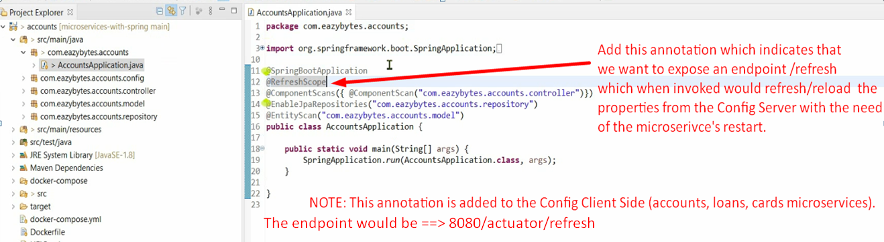
   2. 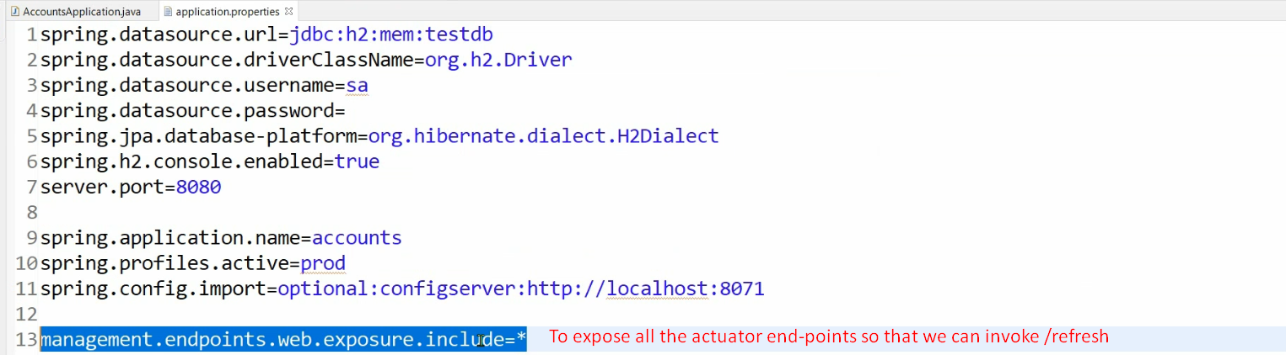  
      NOTE: Do these two changes in other microservices too (loans, cards)
5. 
6. 
7. **NOTE**: This is not possible for all kinds of properties.   
   For example, DB properties. If you change, you need to restart your microservices as DataSource is generated at the startup of a micorserivce.
8. **Question**: If you have 100 instances of a microservice. Are you going to call /refresh on each instance.
9. **Answer:** Write Shell Script, or do something with docker compose file to avoid this.